Name: ________________________________ Date: _______________ Blk. ____

Read the following and answer the accompanying questions
Embargo Act of 1807
The Embargo Act of 1807 was an American law prohibiting all export of cargo from American ports. It was designed to force Britain to reconsider its restrictions on American trade. The Embargo act prohibited American goods from being shipped to foreign ports and all foreign vessels from taking cargo at American ports. Foreign imports were not banned, but they mostly ceased because ships would have to return empty. It represented President Thomas Jefferson’s response to the Britain’s Orders in Council (1807) and France’s Continental System, which were severely hurting America’s merchant marines. Also, it was Jefferson’s response to the British attack on the U.S. Navy in the Chesapeake-Leopard Affair. (The British ship H.M.S. Leopard had attacked the U.S.S. Chesapeake without warning, killing three sailors, and three were impressed.) Although it was designed to force the British and French to change their commercial systems, neither country did, and the Act was repealed in 1809. Moreover, the Act failed to prevent the War of 1812.
From the mid 1790s to 1807, American shippers enjoyed their status as the primary neutral carrier between France and Britain while both countries were engaged in the Napoleonic Wars, profiting as both nations purchased American goods and ships. Before the war ended, about $120 million in American ships and cargo were on the high seas on any one day. Jefferson thought that Britain needed the business so badly it would buckle on the impressment issue, where British warships stopped American commercial ships and seized sailors they said were British subjects. The vast British Royal Navy required a large workforce; a need which could not be provided for by volunteer enlistment. British warships stopped American merchant ships; inspected the papers of every crewmember, and carried off those they decided were British subjects. Over 6,000 sailors with American naturalization papers were also taken because Britain did not honor “naturalized citizenship” papers issued by American courts to men born in Britain.
Congress passed the Embargo Act on December 22, 1807, by votes of twenty-two to six in the Senate and eighty-two to forty-four in the House. The South and West were in favor, and the Northeast opposed; the goal was to attack Britain economically for their impressment policy, and also to ensure America’s neutrality in the war. Unfortunately for the aims of the embargo, Britain had an unusually good harvest in 1808, leaving it far less dependent on America than usual. Although the Act succeeded in lessening impressment, it was merely because it caused so many American sailors to become unemployed. New England, a traditional Federalist stronghold, was in an uproar over the Act and turned to smuggling, particularly across the Canadian border. Congress repealed the Act three days before Jefferson left office, replacing it with the Non-Intercourse Act on March 1, 1809, which lifted all embargoes except for those on Britain and France. This Act was just as ineffective as the Embargo Act itself and was replaced again the following year with Macon’s Bill Number 2, lifting the remaining embargoes.
The embargo devastated shipping-related industries, wrecked existing markets, and caused an increase in opposition to the Republican Party. Smuggling was widely endorsed by the public, which viewed the embargo as a violation of their rights. Despite its unpopular nature, the Embargo Act did have some limited, unintended benefits, especially as it drove capital and labor into New England textile and other manufacturing industries, lessening America’s reliance on the British.

- What was the Embargo Act designed to do?

- What impact does the Embargo have on foreign imports?

- What were Jefferson’s reasons for passing the Embargo?

- How did the U.S. benefit from the fighting between France and England?

- What were the reasons the British had for impressing our ships?

- Which regions of the U.S. were in favor of the Embargo and which were against it? Why would the regions feel differently about this idea?

- Analyze to what extent the Embargo was successful. Discuss ways in which it benefited the U.S. and ways that it hurt the U.S.

Political Cartoon Analysis
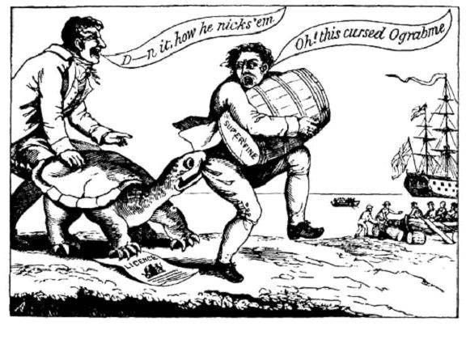
Answer the following questions using the political cartoon above

- The snapping turtle represents the Embargo Act of 1807. Who does the man with the barrel represent? What is he trying to do? Note the ship waiting offshore.

- To which country does the ship belong? How do you know this? What do you think the ship is waiting for?

- Why do you think Embargos were often times depicted as turtles in political cartoons?

- From the tone of the cartoon, do you believe the artist is for or against the Embargo Act? Explain your answer.

